Different English Accents
English is spoken in 75 countries and about 1 billion people from all around the world speak English as a second language. Consequently, many different accents exist. Here are 21 examples of English accents spoken by Amy Walker (turn on “CC” while watching):
https://www.youtube.com/watch?v=3UgpfSp2t6k (2 mins)
1) London, England (Middle class)
2) London, England (Working class / Cockney)
3) London, England (Elite / Upper class)
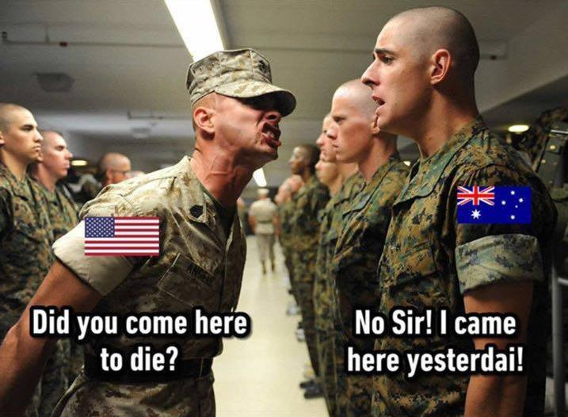
4) Dublin, Ireland (Irish)
5) Belfast, Northern Ireland
6) Scotland (Scottish)
7) Italy
8) Berlin, Germany
9) Prague, Czech Republic
10) Moscow, Russia
11) Paris, France
12) Sydney, Australia (Middle class)
13) Wellington, New Zealand
14) Australia (Working class)
15) Texas, USA
16) California, USA
17) Seattle, Washington, USA
18) Toronto, Canada
19) Brooklyn, New York, USA
20) Charleston, South Carolina, USA
21) 1945 general American accent

Here are some more examples from YouTube. Listen to about 30 seconds of each video.
American: https://www.youtube.com/watch?v=vliGNG204nc
British: https://www.youtube.com/watch?v=ttIa7KEgZsI
Scottish: https://www.youtube.com/watch?v=Kuqrj8uBZ5U
Irish: https://www.youtube.com/watch?v=YNklDOCkXTs
Australian: https://www.youtube.com/watch?v=ZrPV7CI7WTs
https://www.youtube.com/watch?v=CxQZguo1kFg
South African: https://www.youtube.com/watch?v=WZdVSEZnQ3g
New Zealand: https://www.youtube.com/watch?v=fA_IZv0jqzY
Nigerian: https://www.youtube.com/watch?v=K986ZVGVAEc
Indian: https://www.youtube.com/watch?v=7UJpO3VJACc (female voice)
https://www.youtube.com/watch?v=6j3TuLfCrNg (male voice)
Cockney (London): https://www.youtube.com/watch?v=2aT-8Gxn_N8
https://www.youtube.com/watch?v=1WvIwkL8oLc

Now listen to Michael McIntyre making jokes about different accents:
https://www.youtube.com/watch?v=lzymb0YJp7E (8 mins)

